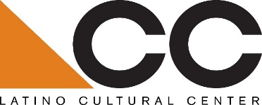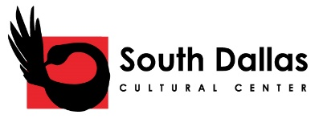

Call for South Dallas Cultural Center and Latino Cultural Center Literary Series Proposals:
The Latino Cultural Center and South Dallas Cultural Center are seeking proposals from Dallas-based literary and/or literature collectives for an ALAANA* based literary series at both cultural centers from October 2019 to May 2020.
Eligibility:
Preference will be given to Dallas-based literary and/or literature collectives that have planned ALAANA-based literary series in Dallas.
Submission guidelines:
Please submit a minimum 150-word description with a fee proposal, including organizational mission, proposed artist(s), and previous experience working with Dallas-based cultural centers and/or organizations. All proposals must be submitted to Benjamin Espino, Manager, Latino Cultural Center via email: benjamin.espino@dallascityhall.com.
Submissions will be accepted beginning September 20, 2019
Submission Deadline: September 27, 2019
Selected candidate will be notified by email on October 1, 2019
About the South Dallas and Latino Cultural Centers:
As a divisions of the City of Dallas’ Office of Cultural Affairs, the Latino Cultural Center and South Dallas Cultural Center serve Latinx visual arts and arts/cultural organizations and African American visual artists and arts/cultural organizations, respectively.

OCA vision: An equitable, diverse, and connected community, whose residents and visitors thrive through meaningful arts and cultural experiences in every neighborhood across Dallas.
https://dallasculture.org/

