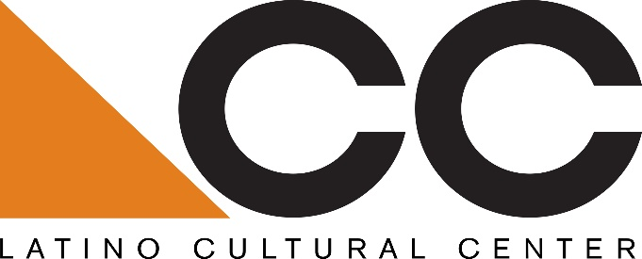

Call for Musical Artist Presentation/Performance:
The Latino Cultural Center is seeking proposals from Texas arts and cultural organizations for the following service: an accordion contest showcase for Latino/a students and a concert by a Dallas-based Tejano band and/or Texas-based Tejano band on March 21, 2019 from 4 pm to 9 pm.
Eligibility:
Preference will be given to Texas-based nonprofit arts and cultural organizations that have worked to plan accordion contest showcases for Dallas-based Latino/a students and have a prior history of working to organize Tejano concerts/cultural events in tandem.
Submission guidelines:
Please submit a minimum 150-word description with a fee proposal, including organizational mission, proposed artist(s), and previous experience working with Dallas and regional Latino/a arts and cultural venues and/or organizations. All proposals must be submitted to Benjamin Espino, Manager, Latino Cultural Center via email: benjamin.espino@dallascityhall.com.
Submissions will be accepted beginning Friday, January 25, 2019
Submission Deadline: Thursday, January 31, 2019
Selected candidate will be notified by email on Thursday, February 14, 2019
About the Latino Cultural Center:
As a division of the City of Dallas’ Office of Cultural Affairs, the mission of the Latino Cultural Center is to serve as a regional catalyst for the preservation, promotion and development of Latino/a and Hispanic arts and culture. Designed by internationally recognized Mexican architect Ricardo Legorreta, the 27,500 square foot facility features a 300-seat auditorium, outdoor plaza, and two galleries spaces.

OCA vision: An equitable, diverse, and connected community, whose residents and visitors thrive through meaningful arts and cultural experiences in every neighborhood across Dallas.
https://dallasculture.org/

